Tracing the Steps of the Successful Multilingual
—A Synopsis—
Charles M. Mueller

The trees of Ox Mountain were once beautiful . . .
yet when people now see it, they think it was originally barren.
But is this the true nature of the mountain?
Mencius

Introduction

Mencius, writing on the innate goodness of human nature, likened human evil to Ox Mountain. According to the ancient Chinese sage, the mountain, which by his time had become barren, originally had not been so. Rather, its barren nature was due to men, who chopped down the trees and allowed animals to overgraze.
If human language acquisition is viewed as an organic process, multilingualism might be regarded as one possible outcome from this process; however, like the trees of Ox Mountain, multilingualism requires a specific environment and facilitating factors if it is to flower. This paper examines how these factors operate within the histories of successful multilinguals.

Factors Facilitating Development of Multilingual Proficiency

Research on multilinguals has discussed a number of factors thought to facilitate the development of multilingual proficiency. Many of these factors are external to the individual. For example, language learners rely on institutional support such as temples or churches, recreational groups or schools, or networks of people using the same language. Learners are also influenced by the perceived status of a language. Giles, Bourhis and Taylor (1977) refer to such institutional support, demographic support and status as “ethnolinguistic vitality.” Language can also be used to mark one’s identity within a specific group or as a steppingstone to a better career.
Such factors outside an individual’s control have a significant influence on the development of multilingual ability, yet this is not the whole story. It is easy to find people brought up in comparable circumstances and provided with similar opportunities who differ in their degree of multilingual attainment. To account for such variances, researchers have examined a number of individual factors. The current study dealt with five of these: motivation, confidence, cultural affinity, interest in languages and strategy use.
This study adopted Kanfer & Ackerman’s (1989, p. 661) definition of motivation as, “The direction of attentional effort, the proportion of total attentional effort directed to the task (intensity), and the extent to which attentional effort toward the task is maintained over time (persistence).” Factors such as confidence, cultural affinity and interest in languages are usually discussed as part of the single factor of attitude, which Chambers (1999, p. 27) defines as “. . . the set of values which a pupil brings to the foreign language learning experience.” This study adopts this definition with the proviso that these attitudes are understood as mutable throughout the language acquisition process. In this paper, the term confidence is used to refer to an individual’s sense of poise and self-assurance within the language acquisition process. Cultural affinity refers to the sense of psychological distance from the culture of the target-language. An interest in language refers to a linguistic fascination on an abstract level that transcends the immediate communicative needs of language learning.
The current study therefore focused on the ten factors in Figure 1 below:

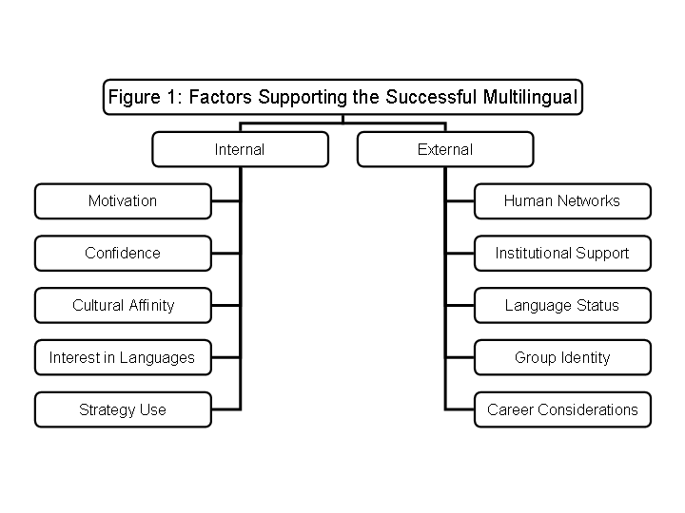

Two-tiered Study of Successful Multilinguals

The study consisted of two phases. The first phase used a two-page questionnaire to collect general data from 23 successful multilinguals. The data were used to create a general typology, which in turn was used to select participants for the second phase of the study involving in-depth interviews with six highly-proficient multilinguals. From these interviews, three were selected as best representing the distinct avenues to multilingualism that emerged from the data.

Research design and participants

This study used an exploratory-interpretive method characterized by a non-experimental design. In doing so, it adopted a historical approach employing qualitative data subjected to interpretive analysis. All participants receiving the questionnaire were multilinguals with a high level of proficiency in at least two languages. This proficiency was attested to by both their ability to use at least two languages within academic environments and a self-assessment of an ILR (Interlanguage Language Roundtable) proficiency level of at least Level Three in a language beyond their native language. All participants had at least a four-year college degree.

Instruments and method

For the first phase of this study, a two-page questionnaire was given to 23 respondents. Page 1 of the questionnaire, based on a similar questionnaire published by Rubin and Thompson (1994, pp. 72-73), asked questions about respondents’ use of three metacognitive strategies (planning, problem solving and monitoring) with five questions per topic. Page 2 asked biographical information on respondents’ language acquisition. This included a self-assessment using the ILR scale and information on the impetus for acquisition of multiple languages.

Data and analysis

On the questionnaire, the 20 respondents selected for the study tended to report substantial use of metacognitive strategies. There were five questions for each of the three strategies with a scale of 1 (little use of the given strategy) to 5 (significant use). Respondents averaged between 18.05 and 19.58 from a possible total of 25. There was little variation among individual respondents in degree of strategy use. The types of strategies employed were similar, with slightly higher results (19.58 and 19.47) indicated for monitoring and problem solving respectively. Alexander, a heritage speaker who had never extensively studied another language, did not fill out the front of the questionnaire dealing with strategy use. He explained that he was not aware of strategies that he had used since he had learned the language from birth without the need for formal study.
A tally of the biographical information showed that in 39% of the cases (excluding respondents’ native language), the respondents had begun studying a language for academic purposes. In another 39%, personal interests (use of language to socialize, learn about culture, travel, etc.) were the reasons cited, while heritage accounted for 12% and practical reasons (survival, work) accounted for 9%. In Phase 2 of the study, the three respondents were selected so that their reasons for acquisition of multiple languages (when taken together) would roughly correspond to that of the larger group.

Figure 2: Tally and Averages of Totals for Questionnaire Respondents of Phase 1
Totals  Averages | Planning  342  18.05 | Monitoring  372  19.58 | Problem  Solving  370  19.47 | Academic | Academic = 13  Social = 6  Personal interest = 4  Self-development = 2  Travel = 1  Home/Heritage = 4  Survival = 2  Job = 1
 |  |  |  | Interests
 |  |  |  | Family
 |  |  |  | Practical

Data from the three interviews

During the second phase of the study, in-depth interviews were conducted with three multilinguals. Summaries and a discussion of the interviews follow.

Three Paths to Successful Multilingualism: Alexander, Megan and Aaron

Alexander

Alexander is an American heritage-speaker of Russian in his 50s who currently teaches Russian at a language institute. His father was a Russian POW in Germany, so Alexander’s first languages were German and Russian. At the age of 3, his family moved to the United States where he was brought up in a small community of Russian émigrés.
When Alexander was young, human networks played a vital role in his linguistic development. Prior to entering kindergarten, he spoke mostly Russian with the other children in his neighborhood, and the language was also used to speak to friends’ parents and on Sundays at the Russian Orthodox Church. Alexander’s father, a former professor of Russian, absolutely insisted that his son speak only Russian at home. (Alexander can even recall his father saying half-jokingly that he could not start eating until he gave the instrumental case for a certain Russian verb.)
Alexander’s father contributed to the development of institutional support by setting up a Russian Saturday school on the college campus. In the class, Alexander formally learned Russian, including composition, spelling, grammar, geography and culture. Alexander was not particularly motivated to attend these classes, but he says that he came to appreciate his time with fellow students as many of these early relationships with fellow heritage-speakers grew into life-long friendships.
Alexander always thought of himself as exclusively American, and as he grew up, he did not feel much affinity with Russian culture, but he did have an interest in language. Alexander majored in geography and Russian at the university. He tested out of Russian classes and worked as a teaching assistant. In this job, he learned how to teach Russian grammar from a pedagogical standpoint. This knowledge helped him when he became a teacher at the school where his father taught.
An examination of Alexander’s narrative history shows strong external factors driving his initial acquisition of the language. It is interesting to note that he achieved high proficiency in Russian in spite of his initial lack of intrinsic motivation or a sense of cultural affinity. In his case, strong human networks and institutional support seem to have sustained his early learning, and this language proficiency was further enhanced and maintained due to his career choice, which was only possible because of the high status Russian enjoyed as the language of the other superpower during the Cold War. The following diagram charts Alexander’s development of Russian proficiency:

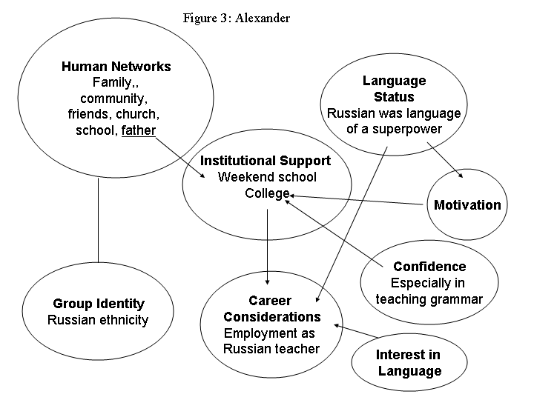

Megan

Megan is a native Korean speaker in her 20s currently doing her master’s degree in translation and interpretation with English and Korean as her working languages. She has a high level of proficiency in both Chinese and English. Megan reports that she found high school language classes (English and German) to be easy, and this led her to believe that she had a natural aptitude for languages. In high school, she also became interested in Chinese cinema. During her college years, South Korea opened up diplomatic relations with China. Megan therefore decided to major in both Chinese and economics at the university.
In her junior year of college, Megan went to Beijing as an exchange student. She was shocked to find that her university study of Chinese had not adequately prepared her. For the next six months, she spent every waking minute deeply immersed in studying Chinese and speaking with Chinese friends. At the end of this time, she suddenly found that she could speak about and understand virtually anything she heard. She easily acquired excellent pronunciation, to the extent that Chinese people would often mistake her for a native speaker. She also had a close non-romantic relationship with a male Chinese friend who took a genuine interest in getting to know her well. She reports learning Chinese without much hardship, finding it easier since the Chinese share the same Confucian culture as Korea.
Megan considered becoming a Chinese interpreter, but felt the demand for Chinese was not high enough, so she chose to study English, the global language. When she went back to Korea, she therefore devoted more time to English, attending an English institute. Her proficiency eventually improved to the point that she was able to matriculate to a U.S. graduate program.
Megan’s narrative begins with strong internal factors such as confidence and a sense of cultural affinity (but with little interest in language itself). In China, human networks (close friendships), institutional support (the exchange program) and a sense of close cultural ties (Korea and China share a Confucian heritage) help her to rapidly develop fluency. Chinese is also a high-status language. Even so, the status of English as a global language eventually causes her to abandon Chinese and learn English. When learning English, institutional support facilitated the acquisition of academic English yet she reported being more fluent in Chinese. She attributed this to the closer personal ties she enjoyed in China. The chart below shows Megan’s development of Chinese and English proficiency.

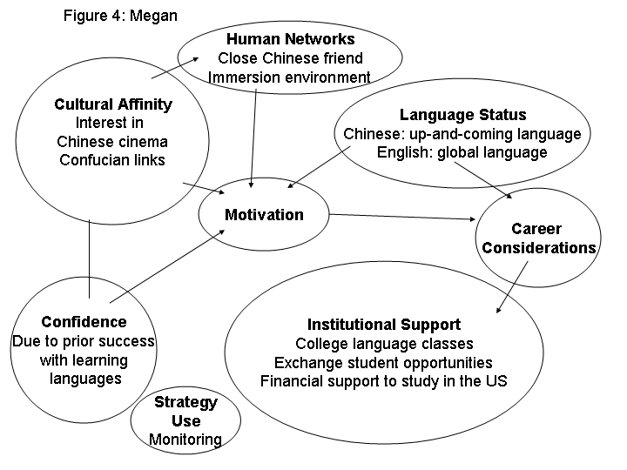
Aaron

Aaron is from the former Yugoslavia. He has taught Russian and Old-Church Slavonic at the university level and currently teaches Croatian at a language institute. Aaron grew up in Bosnia where both Croatian and Serbian exist as language varieties. He learned early in life that, although the languages were similar, they were important as indications of identity within a specific ethnic community.
In Aaron’s village school, he learned Russian from 5th to 12th grade and for four years in college. The study used solely textbooks with occasional songs. During his university days, Aaron traveled on short student exchanges to Russia. In spite of his initial shock at witnessing Russia’s oppressive political climate and poverty, Aaron felt motivated to learn the language, partly due to personal romantic interests. In spite of some initial friction, Aaron grew to like Russian culture. At one point, he found a high-level book on psychology and found, to his great joy, that with a little dictionary use he could understand everything in it! This experience boosted his self-confidence.
After completing his B.A., Aaron enrolled in an M.A. program in Yugoslavia doing a double major: one in General Linguistics and another one in Polish. Aaron liked Polish (despite mediocre professors) as he felt a particularly close connection with the people he met when he visited Poland and developed a deep connection with Poland’s “refined, polite and noble culture.” A pivotal event in his love of Polish was coming across a bookstore in Krakow that he describes as “paradise”—a bookstore full of high-level books on philosophy, theology and science, all priced very reasonably. During the years he was active in academic circles, Aaron learned other languages while on academic visits to various countries, developing conversation ability in Bulgarian, Macedonian, French and Albanian while learning pieces of other languages related to his studies.
While in Yugoslavia, Aaron met and married an American woman who spoke Croatian and Russian. They eventually moved to the U.S. where they lived for the next six years. Aaron’s wife spoke Croatian with him even in the U.S., but spoke English with their two children. When Aaron came to the U.S., he knew only a few words of English. He tried to learn by reading everything he saw but, not knowing how to pronounce words, became very frustrated, feeling that he had many thoughts that he was unable to express. This frustration influenced his thinking about the U.S. at the time, leading to a negative impression. His circle of friends consisted solely of Russian professors. Aaron’s English did not improve significantly until after his divorce when he was forced to use English exclusively to interact with American society at large.
In Aaron’s history, group identity is an important factor in his early linguistic development. Language is bound up with national identity as a Croat, with ethnic Slavic identity and (in the case of early Latin studies) with a Catholic religious identity. High-status international languages such as Russian and English, on the other hand, served as vehicles to transcend this limited nationalist identity. The cultural affinity he feels for certain languages (e.g., Polish) is often trumped by practical career considerations that are in turn influenced by language status, as in the case of Russian and English. Aaron has an intense love of language in general. The following chart traces the major outlines of his linguistic development.
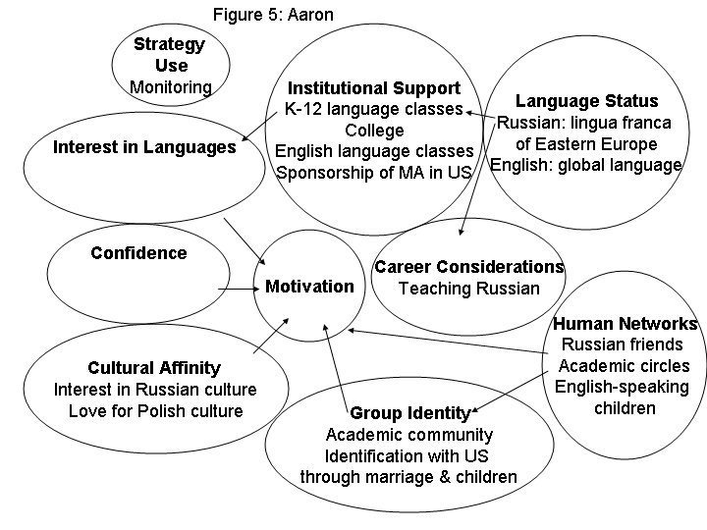
Implications

This study has examined the narrative history of three successful multilinguals. In the course of the interviews, five internal and five external facilitative factors have emerged as particularly salient aspects of the learners’ narrative histories. The three multilinguals in this study have traversed diverse paths to success. Megan, for example, reports the importance of her close friendships in helping her acquire Chinese, while Aaron mentions his excitement associated with being able to read foreign language books and interact with larger domains of academic discourse. Alexander, on the other hand, attributes much of his success to his parents’ stubborn insistence that he converse in Russian.
The narratives all seem to indicate that a great confluence of factors must occur if a person is to attain a high level of multilingual proficiency. In the field of language teaching, we need to acknowledge these factors. The diverse avenues of multilingual success in such narratives suggest that there may not be any set path to foreign language acquisition. Rather, each person must draw on different sources of support. As teachers, we need to learn how to enhance these facilitative factors within the particular context of each individual. At the same time, we need to understand how these factors change and develop over time. Such an understanding creates the basis for helping learners reach high levels of multilingual proficiency.
References

Chambers, G. (1999). Motivating language learners. Sydney, Australia: Multilingual
Matters Ltd.
Giles, H., Bourhis, R.Y. & Taylor, D.M. (1977). Towards a theory of language in
ethnic group relations. In H. Giles (Ed.), Language, ethnicity and intergroup
relations (pp. 307-48). New York: Academic Press.
Kanfer, R. & Ackerman, P.L. (1989). Motivation and cognitive abilities: an integrative/
aptitude-treatment interaction approach to skill acquisition. Journal of Applied
Psychology Monograph, 74, 657-90.
Mueller, C. (2003, May). Tracing the steps of the successful multilingual. Paper
presented at First Annual Symposium on Nativelike Foreign Language
Acquisition , Monterey, CA.
Rubin, J. & Thompson, I. (1994). How to be a more successful language learner.
Boston, MA: Heinle & Heinle Publishers.

My own translation from the Classical Chinese.
Such practical considerations are often discussed in terms of an individual’s extrinsic motivation to learn a language. In this paper, however, career considerations are considered as external since the individual learner has little control over economic evaluation of specific linguistic abilities within a given society.
Three of the original 23 respondents were excluded, having failed to meet language proficiency criteria.
The numbers of reasons in the far right column of Table 2 exceed the number of respondents since these were reported separately for each language (besides native language) that the respondent knew.

